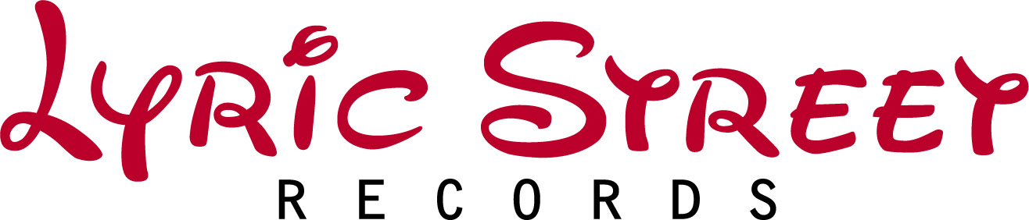

PHIL STACEY
Album Title: Phil Stacey
Single Title: “If You Didn’t Love Me”
Producer: Wayne Kirkpatrick
Street Date: April 29, 2008

- Phil Stacey finished 6th last season (Season 6) on American Idol, where he performed for an average of 30 million viewers each week.

- Phil’s CD was produced by Grammy-award winner Wayne Kirkpatrick (Eric Clapton’s “Change The World”).

- Phil’s debut single, “If You Didn’t Love Me” was co-written by labelmate Gary LeVox of Rascal Flatts and is rapidly climbing the country radio charts.

- On Country Music Night on Idol last season Judge Randy Jackson raved after Phil’s performance, “You are going to have a career in country music!” Also on Idol, Tony Bennett called Phil, “One of the better singers I’ve heard, not just today, but in a long time.”

- Phil made his Grand Ole Opry debut in Nashville on March 27th.

- Following his time on American Idol, Phil toured with his fellow contestants over the summer on the 55-city American Idol tour.

- Phil has been featured on Live with Regis & Kelly, The Tonight Show with Jay Leno, Ellen, The Today Show, Larry King Live and Nickelodeon’s MeTV.

- In 2003, Phil enlisted in the United States Navy where he served as a Musician Third Class, and was stationed at Navy Band Southeast in Jacksonville, Florida. He just completed his 4 year commitment to the U.S. Navy and is still in the Navy Reserves.

- Born in Harlan, KY and raised in Ohio and Kansas, Phil currently lives in Nashville with his wife Kendra and two daughters, McKayla and Chloe.

To listen now to Phil’s current single “If You Didn’t Love Me” from his upcoming debut CD, log on to www.philstacey.com

To download images, view video clips and listen to new music visit www.lsrmedia.com (password: willie!)

