How Olive Oil from Spain Gets
from the Tree to Your Table

The olive oil making process may have never crossed your mind. However, the leading producer of olive oil – Spain – takes great pride in creating a quality product and has for more than 2,000 years. Checking the back of the olive oil bottle to confirm that Spain is the country of origin will ensure you’re getting quality oil made from the world’s most famous olives. Here’s a look at how Spain produces nearly 1,000,000 tons of olive oil from more than 300 million olive trees each year.

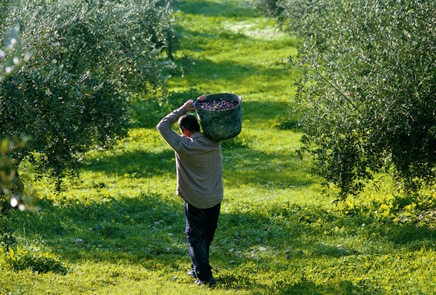 | From the Olive Tree  - An olive tree reaches maturity at about 20 years, but begins producing olives between five and 10 years. The age of the tree influences the quantity of olives produced, but does not affect quality. In fact, many trees produce olives for 100 to 150 years, but the older they get, the less they produce.
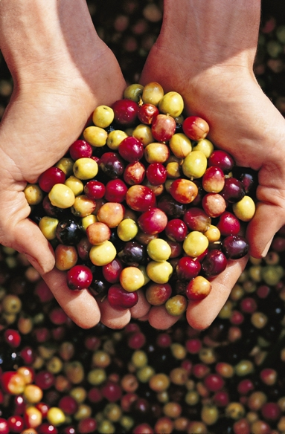 | What Does the Color Mean?  - An olive’s color indicates the stage of its ripeness (not its variety) and let’s you know when it’s ready to harvest. Olives start out green and turn black as they ripen. If visiting Spain in the spring, olive trees will be in bloom. Harvesting occurs in the beginning of winter when the color of the olive turns black. However, some olive varieties maintain a greenish color throughout the ripening process.
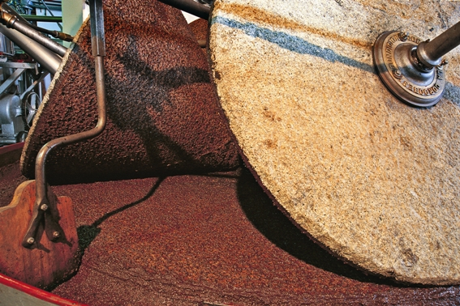 | How is Olive Oil Processed?  - After harvesting – generally within 24 hours to ensure the highest quality oil – olives are transported to a mill to begin the extraction process. Olives run along a conveyor belt and are selected based on quality. Next, they are washed in water and the grinding process begins to create a paste. The olive paste is pressed through a continuous system to separate the oil from the solids. The oil obtained is stored in cellars until it’s ready to go to market.
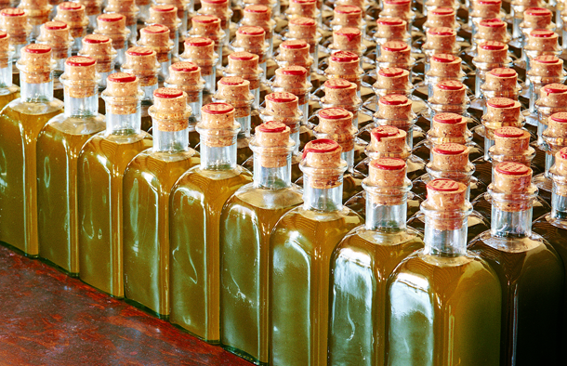 | To the Table  - Finally, the oil gets to your table. Keep in mind that olive oil is affected by air, light and heat, so it should be kept in a closed container at room temperature and out of direct sunlight. A natural product, olive oil does not improve with time, so enjoy within a year to 18 months.

# # #

Contact: Marisa Baile, 312-988-2425, mbaile@webershandwick.com

