Olive Varietals from Spain
There are 262 varieties of olives cultivated in Spain, although only 24 are used regularly in the production of oils. The most important varieties produced include Picual, Hojiblanca, Lechin, Picudo, Arbequina, Cornicabra, Verdial and Empletre. Each variety in turn produces an oil distinctive in color, flavor and application.
Name | Region | Flavor Profile | Characteristics | Usage | Key Facts
PICUAL  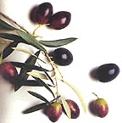 | Production is concentrated in Jaén and neighboring provinces over 1.6 million acres. | Tends to have more body, with a slightly bitter taste and a hint of wood. | Name comes from the shape of the olive, with its pointed tip. Medium to large in size. | Best used in frying, although it is equally good for salads and gazpachos. | The most important olive variety, Picual accounts for 50 percent of production in Spain and 20 percent of the world’s production. It is one of the most stable varieties in the world, due to its high content of naturally occurring antioxidants.
HOJIBLANCA  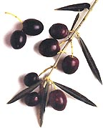 | This olive is grown in the eastern part of Seville, the south of Córdoba and the north of Málaga over an area of 540,000 acres. | Known for having a large variety of flavors, including a light sweet taste in the beginning, a light bitter taste of unripe fruits and an almond aftertaste. | Large in size, the name comes from the white underside of the leaves. | Recommended for frying, it is also ideal for making bread, pasta and pastries due to the perfect consistency it gives to dough.  The olives themselves are widely used and appreciated as black table olives. | This olive accounts for 16 percent of Andalusian production.  Produces lower saturated fatty acids than most other oils.
LECHIN  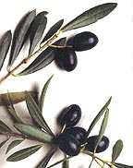 | Occupies more than 157,000 acres in the province of Granada and a small part of Seville. | Slightly bitter, leaving an aftertaste of green almonds. | Name refers to the milky white color of the flesh of the olive. | In Spain, the oil is used frequently in the preparation of tapas. Also ideal for sweets. | Oil content is approximately 18%.

Name | Region | Flavor Profile | Characteristics | Usage | Key Facts
PICUDO  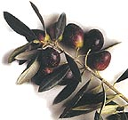 | Mainly cultivated in Baena and the southern part of Córdoba. About 150,000 acres are planted. | Soft, with an exotic fruit aftertaste.  The sweet flavor of the ripe fruit is reported to attract birds. | Name comes from its shape, with a curved pointed tip. | This oil works well in warm salads and pastries. And, these olives are excellent as table olives, green and black. | This olive is typically used in production with a Picual—actually in a “coupage” or blend. It adds smoothness to overall flavor.
ARBEQUINA  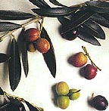 | Originally from the town of Arbeca in Lérida, these olives are cultivated in Lérida, Huesca, Tarragona and Zaragoza. | Dense and fluid, tasting of orchard fruits. | This olive has an oval shape and is small in size. | Since its aromatic substances are very volatile, this oil is best used uncooked. It combines perfectly with raw or cooked vegetables and grilled fish. | This olive is very highly regarded due to its relatively high oil yield.
CORNICABRA  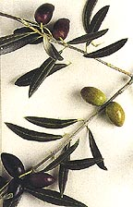 | Production area is distributed throughout provinces of Toledo and Ciudad Real. | Known for its fruity flavor. | This olive is horn shaped, long and slightly curved. Golden in color with greenish tones | An oil perfect for warm salads, stewed vegetables, and for making sauces such as mayonnaise. | Occupying the second largest growing area, it ranks third in level of production.
VERDIAL  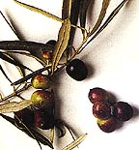 | A number of local varieties produced in Andalusia and the south province of Bdajoz | Sweet and very fruity with no bitter flavor. | The fruit is large and makes an ideal variety, not only for oil, but also as table olives. | Since it is an early oil, it is ideal for salads. | Large fruit which needs to be protected from heat, light and air. In some areas, it is mixed with the Hojiblanca variety resulting in the most exclusive oils.
EMPELTRE  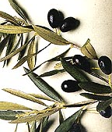 | Cultivated throughout the valley of the Ebro River. | Sweet and aromatic, this oil has no bitter taste. | Long, asymmetrical fruit that is slightly bulging on the back. Smooth, pale yellow in color. | A virgin olive oil, it is ideal for sauces, marinades, vinaigrettes, or to add a special touch to boiled or steamed dishes. | Ideal for mixing with stronger oils, this oil is best to be consumed quickly.

